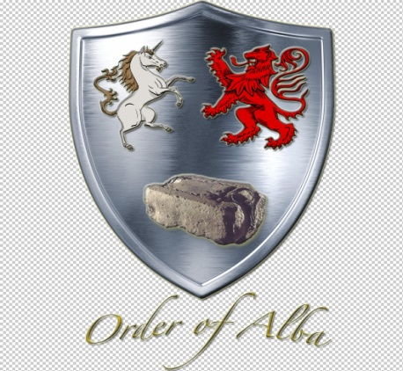

JOURNAL OF ALBA
Volume 2, Issue 1 - Summer 2019 Edition

From the Office of the President General,

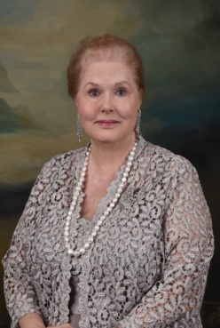
It is with gratitude and excitement I accepted the Order's leadership at the Annual Gathering this past April. Thank you for the privilege to serve Order of Alba. Inaugural Honorary President General Charles Poland has set a high bar of excellent leadership and service to follow. It is my humble commitment to continue to meet the goals he has set before the Order. Thank you to the members for electing a magnificent Board of Officers to carry duties of the Order in this administration. Already they have been occupied in turning over the duties by transferring files, changing bank account signers, filing incorporation papers, amending the directory, verifying new members, and making site arrangements for the 2020 Annual Gathering followed by the Royal Seven Gala next year.

Please mark your calendars, make your travel and lodging arrangements, and plan to attend on Monday, April 13, the day after Easter Sunday. Order of Alba will initiate the individual business sessions with ours beginning at 4:00 pm. The plan is for this epic event with several other national organizations to open the Main Hereditary Week. Please make it your priority to join in the fellowship.

Membership growth is key to the continued success of the Order. Please invite your family and friends to apply Order of Alba.

The following abstract of the minutes of the Annual Gathering is included for information for those who were unable to be present, and to refresh the memory of those members were attendance. Please send any amendments to former Secretary General Ann Scott Garner who is the current Chaplain General.

"Haste ye back" for the Annual Gathering next year.

Carla Whitehurst Odom

Order of Alba
Annual Gathering
9 April 2019
The Army and Navy Club, Washington, DC
(as abstracted from the pdf copy)

The Fourth Annual Gathering of the Order of Alba was held at The Army and Navy Club on April 9, 2019. Founding President General Charles Poland gave a warm Scottish greeting to all. House of Wessex Chaplain General Rodney Wilson gave the invocation. The ritual followed.

National leaders were invited to stand, introduce themselves, and state the society they lead.

President General Poland introduced the officers of the Order of Alba. Reports followed. Minutes of the 2018 Gathering were accepted as read. The Treasurer's report was presented.

President Poland gave an invitation for all to the Tea.

First Vice President General Carla Odom introduced Stefan Zimmers, Ph.D., Assistant Dean of Georgetown College who gave the keynote address, Unity and Wisdom: The Royal Ideology of King Alfred. The Order enjoyed a scholarly treat. President General Poland presented a gift of appreciation from Order of Alba and Order of the House of Wessex.

Unfinished Business: None

New Business: President Poland presented the 2019-2021 slate from the Nominating Committee:

President General - Carla Odom
First Vice President General - Douglass Tim Mabee
Second Vice President - Suzanna Rawlins
Chaplain General - Ann Garner
Treasurer General - Constance Paradiso
Secretary General - Lila Housden
Registrar/Genealogist General - David Grinnell
Chancellor General - Carter Furr, Esq.
Historian General/Insignia Chair - Madeline Alworth
Councilor - Chris Moberg
Councilor - Jane Power

The motion was made and seconded to accept the slate as presented.

The motion was adopted. Installation followed.

President General Carla Odom accepted a motion that Chuck Poland be made Honorary President General for Life. Motion was adopted. President General Odom then presented Honorary President General Poland with a two inch sterling insigne that is a gift from the Inaugural and 2017-2019 Boards of Officers.

There being no additional business for the Order of Alba the Annual Gathering was adjourned.

Ann S. Garner
Secretary General

Saint Andrew's Cross, adopted in the 15th century, the Saltire is the Flag of Scotland

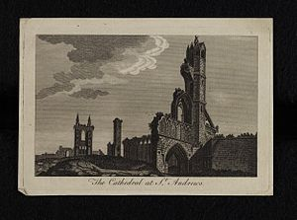

(St. Andrew's Cathedral, Scotland)

Saint Andrew, Patron Saint of Scotland

Carla Odom, DTJ

St Andrew and his brother St. Simon Peter were fishermen, born in Bethsaida to John/Jonah and Joanna. The family later moved to the Capernaum region near the spring Capharnaum. Few details are verified about his early life. Prior to becoming a follower of Christ and an apostle, Andrew was a disciple of St. John the Baptist. He is credited as being the first disciple called by Jesus. He is considered the Patron Saint of Fishermen and Spinsters. It is believed he spent many years on the mission field in Asia Minor.

When he was sentenced to death in 60 AD, St. Andrew asked not to be crucified on the same cross configuration as Christ, so he died on an X-shaped cross which is today known as the “St. Andrew Cross.” The cross on the Scottish flag represents St. Andrew's Cross. It is also one of the three overlaid crosses on the union flag of the United Kingdom.

It is believed that some relics of Andrew were transported from Constantinople to the modern Scottish town of St. Andrews by a Christian named St. Regulus. Russia, Greece, Romania, and Barbados also hail him as a patron saint of their countries. St. Andrew was tortured by stoning and subsequently was crucified on a cross in Patras, in modern-day Greece. His last recorded words were:
"Accept me, O Christ Jesus, Whom I saw, Whom I love, and in Whom I am.
Accept my spirit in peace in Your Eternal Realm."

The feast day of St. Andrew is observed on November 30th. It is considered the national day of Scotland. In America The Saint Andrew's Society, named for the patron Saint of Scotland, began in Charleston, South Carolina. Over the years several other areas have established Saint Andrew's Societies. The author's husband and grandson are members. The original organization began as an outreach to widows and orphans. It continues that mission while incorporating fellowship and an interest in all things Scottish.

BIBLIOGRAPHY
Saint Andrew

SUMMON'S MISCELLANY SAINTS & SINNERS, compiled by Parminder Summon, William B. Eerdmans Publishing Company, Grand Rapids, Michigan/Cambridge, U. K., 2005.
thewintagenews.com/2016/12/19/the-story-of-st-andrew-the-patron-saint-of-scotland. abstracted
www,Scotland.org/events/ st-andrews-day/who-was-st-andrew
THE SEARCH FOR THE TWELVE APOSTLES, revised edition, William Steuart McBirnie, Tyndale House Publishers, Inc., Carol Stream, Illinois, 1973.

wikipedia.org/wiki/Andrew-the-Apostle

