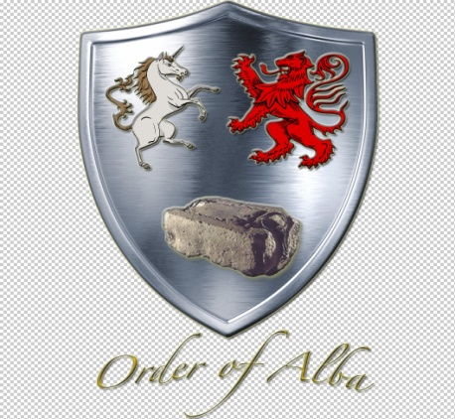

JOURNAL OF ALBA
Volume 2, Issue 3 - Christmas 2020 Edition
From the office of the President General

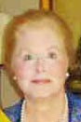
Greetings Fellow Members,

From our house to yours I send warmest wishes for a joyful Christmas and blessed New Year. The Executive Board of Officers has been occupied in a number of activities for the Order this year. In January the Order's Shennachie Bruce Durie, Ph.D. and Founder and Honorary President General Charles Poland served with this officer to select Siobhan Carroll, a faculty member at the University of Delaware, as the Order's first recipient of the King Kenneth MacAlpin Research Grant. Vice President General Tim Mabee is commended for the beautiful Winter 2020 Seventh Edition Directory mailed before the USA outbreak of the world pandemic of COVID. His Eighth Edition of the Directory is included in the series of attachments ready to copy and place with the Seventh Edition. The other officers have faithfully kept good records of all our activities and finances. Last April when the Fifth Annual Gathering was changed to an electronic Annual Gathering a copy of the scripted agenda was provided to the membership with my, the Treasurer's and Registrar's reports which together did provide an electronic Annual Gathering.

Registrar General David Grinnell has continued to encourage candidates through the verification process of their applications. He has provided an interesting article that follows for your reading pleasure. Appreciation is extended to the Nominating Committee comprised of Tim Mabee, Chairman, with Suzanna Rawlins and Ann Garner for providing a slate of nominees for the 2021 - 2023 administration. Thank you to everyone who agreed to have their name placed on the slate.

Plans are in place for the next Annual Gathering that was formerly scheduled Monday, April 12, 2021 at The Army and Navy Club. The Annual Gathering will be held in a different format as a ZOOM venue announced well ahead of a March membership electronic meeting. The March electronic meeting will formally present the Slate of Nominations. Members will be provided the opportunity for nominations from "the floor". At the conclusion of the electronic meeting that will be held open about one week, members will be provided the opportunity to cast their votes that will be counted and certified by the Recording Secretary General. Presentation of the 2021-2023 Officers General -Elect and their Installation Service will be held in April at the Annual Gathering via Zoom on Monday, April 12th . This schedule combination will place the Order in compliance with the current Bylaws.

The decision to change the format in venue for the Order of Alba's Annual Gathering has been reached after careful deliberation based upon restrictions for all persons visiting the District except for residents of Maryland, Virginia, Hawaii and Vermont and is expected to continue without exception, at least into the year 2021 with regard to requirements by Mayor Bowser. For persons in compliance with those requirements there are additional restrictions on attendees' room limits for events scheduled at The Army and Navy Club. Many Americans are encouraged by the future vaccines that began this week for select front line medical workers. The decision to change to a different venue for the 2021 Annual Gathering is based upon current District of Columbia wide restrictions that might be more or less stringent in April 2021 together with the health and safety of the membership comprised of all ages of adults.

It has been a high honor to serve as your President General. I would have far more enjoyed greeting you at face to face Annual Gatherings, but remain grateful for the growth and service of the Order of Alba in the past two years. Thank you for your support and continued encouragement during this interesting period of America's history.

Warm wishes for your health and safety!
Carla

Officers of the Order
2019 - 2021

President General Carla Lucille Whitehurst Odom
1st Vice President General Douglass Mather "Tim" Mabee

2nd Vice President General Suzanna Elizabeth Etheridge Rawlins

Chaplain General Patricia "Ann" Scott Garner

Treasurer General Constance Brooks Paradiso

Secretary General Lila Burner Housden

Registrar/Genealogist General David Lawrence Grinnell

Chancellor General Carter Branham Snow Furr, Esq.

Historian General Madeline Elaine Wilson Alworth

Councillor Christopher Willard Moberg

Councillor Jane Routt Power

Founder and Honorary President General Charles Bryan Poland

APpointments

Annual Gathering Arrangements Carla Lucille Whitehurst Odom
Bylaws Sharon Kaufelt Stine
Journal of Alba, Editor Carla Lucille Whitehurst Odom

King Kenneth MacAlphin Research Grant Bruce Durie, Ph.D, Carla Odom, Charles Poland
Order of Alba Directory, Editor Douglass Mather "Tim" Mabee
Parliamentarian Deborah Ann Whitmore Hicks, Esq.

The Origins of the Kingdom of Alba and ThE REST OF EUROPE
David Lawrence Grinnell
22 October 2020

The Origins of the Kingdom of Alba
The origins of the Scots have been the subject of numerous speculations over the centuries, including some extravagant ones. There is one in particular that I find fanciful: an abbot in his Scotichronicon, argued that the Scots were actually descendants from an Egyptian pharaoh, via the legendary princess Scota, who arrived in Scotland after traveling to Iberia and Ireland.¹ In this same work, the saint’s people, the Gaels, were to have landed in the vicinity of Cruachan Feli-called the Mountain of Ireland. These Gaels were said to have conquered Ireland after a series of battles with the Picts. They then followed their conquest of Ireland by invading Britain, conquering Iona before conquering the cities of Rigmonath (St Andrews) and Bellathor (an unidentified Scoto-Pictish palace). Afterwards, their commander named the land and people after his Egyptian wife Scota.
Medieval Scottish genealogies trace the origin of the Scots to Fergus Mór mac Eirc, the legendary founder of Dál Riata.²
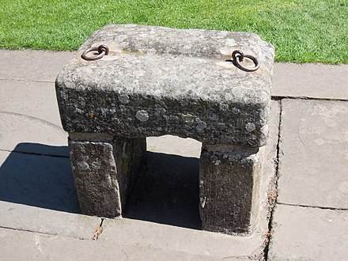
In the Duan Albanach, the tradition of Fergus Mór mac Eirc is re-enforced. It is known to have been written in the reign of King Malcolm III (Máel Coluim mac Donnchada). It recounts the earliest histories of the Picts, and then celebrates the conquest of the Picts by the Gaedhil. It calls the Scottish Gaels the children of Conaire and traces the descent of the Scottish kings from Fergus mac Eirc.³
These mythical traditions were believed in the early modern period and beyond, and even King James VI traced his origin to Fergus, saying, in his own words, that he was a “Monarch sprunge of Ferguse race”.⁴
There is the possibility that Alba is simply a Gaelic translation of the Pictish name for Pictland. Both the Welsh and the Irish use archaic words for Briton to describe the Picts. It is highly likely therefore that the Picts did so themselves. In which case the Pictish for Pictland would have been either the same as their word for Britain, or an obsolete term. Alba was exactly this kind of word in Old Irish. It is therefore plausible that Alba is simply a Gaelic translation. The name change is first registered at the very beginning of the tenth century⁵, not long before Constantine II is alleged to have Scotticised the “Pictish” Church⁶, and at the height of Viking raids. Later records, especially the Chronicle of the Kings of Alba and documents, tell us that the Picts were simply conquered and annihilated by king Kenneth MacAlpin (Cináed mac Ailpín). This is the traditional explanation, and the one repeated by many historians. The only thing which is certain is that before 900, the Cruithentuath (Gaelic for Pictland), and perhaps Fortriu, became Gaelic-speaking Alba.⁷
This brings us up to the modern tradition that the first King of Scots was Kenneth I MacAlpin (Cináed mac Alpín, who founded the state in 843. (Cináed mac Ailpin¹, Causantin mac Cináeda², Domnall mac Causantin³, Máel Coluim mac Domnall⁴, Cináed mac Mail Choluim⁵, Máel Coluim mac Cináeda⁶, Bethoc, Princess of Scotland⁷, Donnchad mac Crináin⁸, Máel Coluim mac Donnchada=Saint Margaret of Scotland⁹, Matilda Maud Princess of Scotland¹⁰, Matilda “Empress Maud of England”¹¹, Henry II King of England¹², John Lackland King of England¹³, Henry III King of England¹⁴, Edward I “Longshanks” King of England¹⁵, Edward II King of England¹⁶, Edward III King of England¹⁷, John Duke of Lancaster of Gaunt¹⁸, Henry Cardinal Beaufort¹⁹, Jane Beaufort²⁰, Katherine Stradling²¹, Walter Dennis²², William Dennis²³, Isabel Dennis²⁴, Elizabeth Berkeley²⁵, Isabel (or Elizabeth) Lygon²⁶, Jane de Bassett²⁷, Frances Deighton²⁸, Benjamin Williams²⁹, Josiah Williams³⁰, Rebecca Williams³¹, Mary Littlefield³², Thomas Wade³³, Daniel Oliver Wade³⁴, Elizabeth Prior Wade³⁵, William Herbert Severance³⁶, Elizabeth Annie Severance³⁷, Mildred Anna Gladding³⁸, David Lawrence Grinnell³⁹)

The House of Alpin (848-1034)
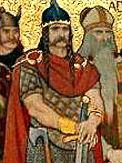
Kenneth I MacAlpin (Cináed mac Ailpin) reigned from 843/8, the assumed founding of the State, until 13 Februay 858. The descendants of Kenneth MacAlpin were divided into two branches; the crown would alternate between the two, the death of a king from one branch often hastened by war or assassination by a pretender from the other. Malcolm II was the last king of the House of Alpin; in his reign, he successfully crushed all opposition to him and, having no sons, was able to pass the crown to his daughter’s son, Duncan I, who inaugurated the House of Dunkeld. The Kings during this period were Kenneth I MacAlpin, 843/848-13 February 858; Donald I, 858-13 Apr 862; Constantine I ,862-877; Áed, 877-878; Giric, 878-889; Eochaid, 878-889?; Donald II, 889-900; Constantine II, 900-943; Malcolm I; Indulf; Dub/Dubh or Duff, 962-967; Cuilén, 967-971, Amlaib. 973-977; Kenneth II, 971-995; Constantine III, 995-997; Kenneth III, 997-25 Mar 1005; Malcolm II, 1005-1034.⁸

The Rest of Europe
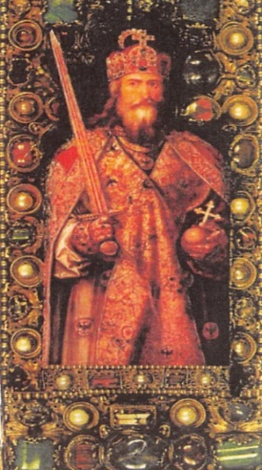
Charlemagne, King of the Franks, 768-814, King of the Langobards, 773-814, Emperor of the Romans, 800-814, had reigned and died at Aachen 28 January 814 and was buried at Aix-la-Chapelle, just 34 years before Kenneth I MacAlpin founded the State of Scotland (Gaelic Alba). His son Pépin (or Pippin), King of Italy, 781-810, was born April 773 and died at Milan 8 July 810. Pépin’s son, Bernard, King of Italy, 812/13-817 was born about 797 and died 17 April 818. His son, Pépin (or Pippin), Count near Paris, seigneur of Péronne and Saint-Quentin, was born in 815-818 and died after 840. Héribert I, Count of Vermandois, 896-900/906, Count of Soissons and lay-abbot of Saint-Crépin, before 898-900/906, was born about 850 and was murdered 11 June between 900 and 6 Nov 907. Héribert II, Count of Meaux, Soissons, and Vermandois and lay-abbot of Saint-Crépin and Saint-Médard, 900/907-943, was born about 880 and dies 23 February 943. Robert, Count of Meaux, 946-after 966 probably died after 19 June 966. His daughter, Adéle of Troyes, married Geoffroi I Grisegonelle, Count of Anjou, 958/960-987; Geoffroi I, Count of Anjou was slain in battle at Marçon 21 July 987. Their daughter, Ermengarde of Anjou, married Conan I, Duke of Brittany, Prince of the Bretons. He was slain at the 2nd Battle of Conquereuil near Nantes 27 June 992. Their daughter, Judith of Brittany, married Richard II, Duke of Normandy, 996-1026; he died at Fécamp 23 August 1026. They had two son: Richard III, Duke of Normandy, 1026-1027 who died 5 (or 6) August 1027; and Robert I the Magnificent, Count of Hiémois, 1026, Duke of Normandy, 1027-1035. By his mistress, Arlette (or Herleve), he had one illegitimate son.⁹
The Frankish dynasties during this period consisted of the Carolingian dynasty (843-888): Charles the Bald, Louis the Stammerer, Louis III, Carloman II and Charles the Fat; the Robertian dynasty (888-898): Odo of Pari; the Carolingian dynasty (898-922): Charles the Simple; the Robertian dynasty (922-923: Robert I; the Bosonid Dynasty (923-936): Rudolph; the Carolingian dynasty (936-987): Louis IV of Outremer, Lothair, Louis V; the House of Capet 987-1060: Hugh Capet, Robert II the Pious, the Wise, and Henry I, son of Robert II.
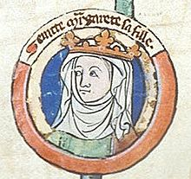

The House of Dunkeld (1034-1286)
Duncan succeeded to the throne of Scotland as the maternal grandson of Malcolm II. He was also the heir general of Malcoml I, as his paternal grandfather, Duncan of Atholl was the third son of Malcolm I. The House of Dunkeld was therefore closely related to the House of Alpin. Duncan was killed in battle by Macbeth; in a series of battles between 1057 and 1058, Duncan’s son Malcolm III defeated and killed Macbeth. On Malcolm III’s death in battle, his brother Donald III, claimed the throne and expelled Malcolm III’s sons from Scotland. After the death of Donald III, Duncan II, son of Malcolm III, ruled until Edgar, another son of Malcolm III, took possession of the throne. Upon the death of Edgar, another of Malcolm III’s sons, Alexander I held the throne from 1107-1124. At his death, the last of Malcolm III’s sons, David I reigned from 1124-1153. After the reign of David I, the Scottish throne was passed according to rules of primogeniture, moving from father to son, or where not possible, brother to brother. Hence, the grandson of David I, Malcolm IV reigned from 1153-1165; followed by another son of David I, William I who reigned from 1165-1214. The Son of William I, Alexander II, ruled from 1214-1249 and his son, Alexander III, ruled from 1249-1286.¹⁰

The Rest of Europe
The illegitimate son of Robert I the Magnificent, Count of Hiémois, 1026, Duke of Normandy, 1027-1035. and his mistress, Arlette (or Herleve) was William the Conqueror, Duke (or Count) of Normandy, 1035-1087, King of England, 1066-1087. He married about 1050, Maud of Flanders, daughter of Baudouin V, Count-Marquis of Flanders, by Adèle, daughter of Robert II, King of France. They had four sons, Robert Curthose [Duke of Normandy], Richard, William II Rufus [King of England] and Henry I [King of England, Duke of Normandy] and five daughters. William the Conqueror, King of England died 9 September 1087.¹¹ His son, Henry I King of England, married Maud of Scotland and had a daughter, Maud of England who married Geoffrey Plantagenet, Count of Anjou and Duke of Normandy. Their son, Henry II, King of England ruled England from 1154 until his death in 1189; he was followed by his son, John King of England who ruled from 1199-1216. It was during John King of England’s reign that the Baron Revolt erupted, forcing King John to sign the Magna Charta. After John died in 1216, his son, Henry III became King of England and ruled until 1272. Henry III’s son assumed the throne of England in 1274. (William I Conqueror of England¹, Henry I ‘Beauclerc’ King of England², Matilda ‘Empress Maud’ of England³, Henry II King of England⁴, John Lackland King of England⁵, Henry III King of England⁶, Edward I ‘Longshanks’ King of England⁷, Elizabeth Plantagenet⁸, Lady Eleanor de Bohun⁹, Lady Petronella Pernel Butler¹⁰, Richard 4th Lord Talbot¹¹, Mary Talbot¹², Sir Thomas Sheriff of Nothamptonshire Greene¹³, Elizabeth Greene¹⁴, Sir Edward Raleigh¹⁵, Sir Edward Raleigh¹⁶, Bridget Raleigh¹⁷, Elizabeth Cope¹⁸, Bridget Elizabeth Dryden¹⁹, Anne Marbury²⁰, Capt Edward Hutchinson²¹, Anne Hutchinson²², Anne Dyer²³, Mary Clarke²⁴, George Wightman²⁵, Mary Wightman²⁶, Sarah Boone²⁷, James Boone Brown²⁸, Edward Greene Brown²⁹, Marie Marble Brown³⁰, Clairmont Livesey Grinnell Jr³¹, David Lawrence Grinnell³²)
The Frankish Dynasties continued with the House of Capet from 4 August 1060 with the Rule of Henry 1; Philip I the Amorous, Louis VI the Fat, Louis VII the Young, Philip II Augustus, Louis VIII the Lion, Louis IX the Saint to Philip III the Bold from 1270-1285.

The House of Sverre (1286-1290)
The status of Margaret, Maid of Norway, as a Scottish monarch is debated by historians. But all agree that because of the lack of Inauguration, her reign never started.

First Interregnum (1290-1292)
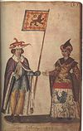
The death of Margaret of Norway began a two-year interregnum in Scotland caused by a succession crisis. With her death, the descent of William I became extinct and there was no obvious heir. Thirteen candidates presented themselves; the most prominent were John Balliol, great-grandson of William I’s younger brother David of Huntingdon, and Robert de Brus, 5th Lord of Annandale, David of Huntingdon’s grandson.

House of Balliol (1292-1296)
The Scottish magnates invited Edward I of England to arbitrate the claims. He did so but forced the Scots to swear allegiance to him as overlord. Eventually, it was decided that John Balliol should be become King.

Second Interregnum (1296-1306)
For ten years, Scotland had no king. The Scots, however, refused to tolerate English rule. William Wallace, John Comyn III and Robert the Bruce (the grandson of the 1292 competitor, Robert de Brus, 5th Lord of Annandale), fought against the English.

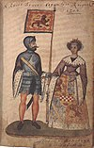
The House of Bruce 1306-1371
In 1306, after Robert the Bruce and his supporters, had murdered his rival John Comyn III, Robert the Bruce was crowned King of Scots at Scone. He was followed by his son David II, King of Scotland 1329-1371.

The Rest of Europe
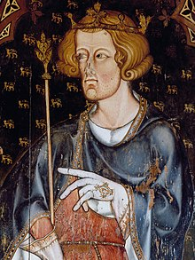
In 1274, Edward I, King of England assumed the throne and reigned until 1307. His son, Edward II, was crowned King of England in 1307 and served until his death in 1327; upon his death, his son, Edward was crowned King of England as Edward III and ruled until 1377. The Frankish dynasties continued with Philip IV the Fair, the Iron King, Louis X the Quarreller, John I the Posthumous, Phil V the Tall, and Charles IV the Fair. The House of Valois (1328-1589) began with Philip VI the Fortunate who reigned from 1 April 1328 to 22 August 1350.

House of Balliol 1332-1356
During the period 1332-1356, several attempts were made to overthrow the House of Bruce; during the minority of David II, Edward Baliol the son of King John Balliol, seized the opportunity to assert his claim to the throne and defeated the the forces of David’s regency and was himself crowned King at Scone in 1332. He was however defeated by loyalist forces and by 1356, renounced all claims to the throne.

House of Stewart/Stuart (1371-1651)
The Stewart era saw periods of royal inertia, during which the nobles usurped power from the crown, followed by periods of personal rule by the monarch, during which he or she would attempt to address the issues created by their minority and the long-term effects of previous reigns. Governing Scotland became increasingly difficult, as the powerful nobility became increasingly intractable. James I’s attempts to curb the disorder of the realm ended in his assassination; James III was killed in a civil war between himself and the nobility. When James IV, who had governed sternly and suppressed the aristocrats, died in the Battle of Flodden, his wife Margaret Tudor, who had been nominated regent for their young son James V, was unseated by noble feuding, and James V’s wife, Mary of Guise, succeed in ruling Scotland during the regency for her young daughter Mary I only by diving and conquering the noble factions. Mary I, the daughter of James V, was forced to abdicate due to her surliness and her favoritism of Roman Catholicism. Upon her abdication her son, fathered by Henry, Lord Darnley, a junior member of the Stewart family, became King as James VI. When his cousin Eliabeth I Queen of England died, he became King of England and Ireland as James I in 1603. Thereafter, although the two crowns of England and Scotland remained separate, the monarchy was based chiefly in England. Charles I, James’s son, found himself faced with the Civil War. The resultant conflict lasted eight years and ended in his execution. The English Parliament then decreed their monarchy to be at an end. The Scots Parliament, after some deliberation, broke their links with England and declared Charles II, son, and heir of Charles I, would become King. He ruled until 1651 when the armies of Oliver Cromwell occupied Scotland and drove him into exile.

The Rest of Europe
King Edward III of England’s son, John of Gaunt, Duke of Aquitaine and Lancaster, had married firstly, Balance of Lancaster, with whom they Henry IV King of England who reigned from 1399 to 1412/13. Henry married Mary de Bohun and had Henry V, King of England who ruled from 1413 to 1422; he married Katherine of France and had Henry VI, who became king of England in 1429 and King of France in 1431. He died in 1471.

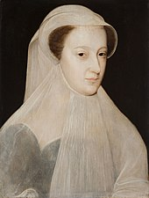
Meanwhile, Henry V’s wife, Katherine of France married secondly, Owen Tudor and produced a son, Edmund Tudor, Earl of Richmond who married Margaret Beaufort, daughter of John Beaufort and Margaret Beauchamp; Edmund Tudor and Margaret Beaufort, had a son who became Henry VII, King of England who ruled from 1485 to 1509. His son ruled from 1509-1547 as Henry VIII. Henry VIII’s eldest daughter by Catherine of Aragon, Mary I because Queen of England. Upon her death, her step sister, by Henry’s later wife, Anne Boleyn, became Queen of England as Elizabeth I and reigned from 17 November 1558 to 24 Mar 1603. Upon the death of his mother, Mary Queen of Scotts who had reigned from 8 December 1542 to 8 February 1587, James VI became King of Scotland on 24 Jul 1567 and upon the death of his cousin, Elizabeth I, Queen of England, became King of England as James I on 24 Mar 1603 and ruled both countries until his death on 27 March 1625.

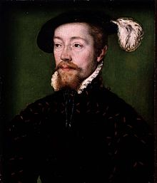
The Frankish dynasties continued with the House of Valois when John II the Good became ruler on 22 August 1350, followed by Charles V the Wise, Charles VI the Beloved, the Mad who ruled from 16 September 1380 to 21 October 1422. From 1422-1453 the rule of France was disputed; the Kings of England claimed the title King of France with the person of Henry VI of England claiming the throne. On the French side, Charles VII the Victorious, the Well-Served, assumed the crown from 21 October 1422 to 22 July 1461, followed by Louis XI the Prudent, the Cunning, The Universal Spider, Charles VIII the Affable, Louis XII Father of the People, Francis I the Father and Restorer of Letters, Henry II, Francis II, Charles IX, and finally, Henry III reigning from 30 May 1574 through 2 August 1589. The House of Bourbon (1589-1792) was the last Frankish dynasties to serve during period of study. It began with Henry IV the Green Gallant Good King Henry, Louis XIII the Just, Louis XIV the Great the Sun King whose reign began on 14 May 1643 and ended on 1 September 1715, son of Louis XIII.

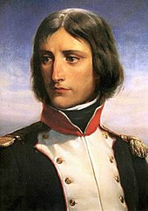
The House of Bourbon would continue with Louis XV the Beloved, Louis XVI the Restorer of French Liberty, to Louis XVII (Claimant). The French First Republic lasted from 1792 to 1804, after which Napoléon Bonaparte, decided to make France a monarchy again.¹²

Most of my research came from Wikipedia, the Free Encyclopedia. I wanted to include what was going on in Spain and the other kingdoms of Europe, but thought better of it when I noticed the length of the existing compilation. Finally, I wish to thank the reader for allowing me to indulge in my own lineage, showing two of my lines; from Kenneth MacAlpin and from William the Conqueror. It is hoped that others might find these lines helpful in their own genealogical search.
¹ Dumville, “St Cathróe of Metz”, pp. 172-6; text translated on A. O. Anderson, Early Sources, vol. 1, pp. 431-443
² Bannerman, Studies (1974) & Dumville Ireland and North Britain (2002)
³ M. Anderson, Kings and Kingship (1973), p. 79
⁴ Pittock, Celtic Identity, (1999), p. 18
⁵ Woolf, Geography of the Picts
⁶ A. O. Anderson, Early Sources, vol. 1, p. 395
⁷ Wikipedia Origins of the Kingdom of Alba
⁸ Wikipedia List of Scottish Monarchs
⁹ Richardson, Douglas Royal Ancestry:A Study in Colonial and Medieval Families (Salt Lake City, Kimball G Everingham, ed.,2013) v:V:483-489
¹⁰ Wikipedia List of Scottish Monarchs
¹¹ Richardson, v:V:490-491
¹² Wikipedia List of French Monarchs

Slate of Nominations for the 2021-2923 Term
Nominating Committee Chairman Douglass Mather "Tim" Mabee serving with
Suzanna Etheridge Rawlins and Ann Scott Garner

President General Douglass Mather "Tim" Mabee

1st Vice President General Suzanna Elizabeth Etheridge Rawlins

2nd Vice President General Patricia "Ann" Scott Garner

Chaplain General Janet Butler Walker

Treasurer General Constance Suzanna Brooks Paradiso

Secretary General Lila Burner Housden

Registrar/Genealogist General David Lawrence Grinnell

Chancellor General unavailable

Historian General Jane Routt Power

Councillor Christopher Willard Moberg

Councillor Carter Branham Snow Furr, Esq.

Founder and Honorary President General Charles Bryan Poland

A request is made from the Nominating Committee to please identify any known attorney in the membership. The nomination for office of Chancellor General remains unfilled at this time.

Scottish Holiday Customs
Before the Reformation in 1560 Christmas was a religious feasting day. One tradition was the baking of unleavened Yule bread for each person. The recipient finding a trinket in their loaf was blessed with a year of good luck.

Houses were decorated with evergreens to brighten them up during the cold, dark season of the year.

Scottish poet Robert Burns wrote "Auld Lang Syne" that is traditionally rendered on New Year's Eve.

