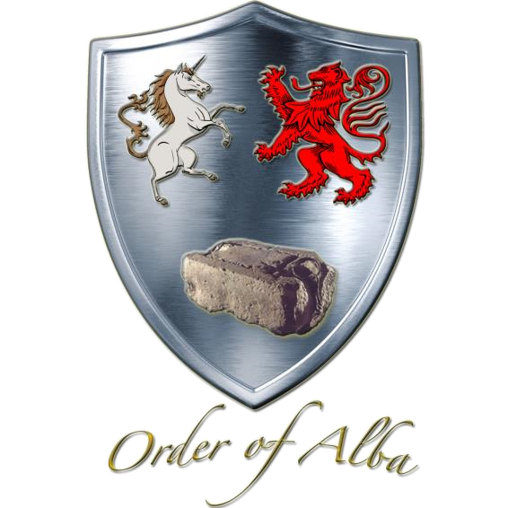

JOURNAL OF ALBA

*Volume 2, Issue 2 - Holy Week to April 13, 2020 Special Online Edition*

of the

Fifth Annual Gathering

Order of Alba

**CALL TO ORDER**

**The Fifth Annual Gathering of the Order of Alba is called to order. I am Carla Whitehurst Odom, President General. Please note the following statements are abstracted from the scripted agenda that was prepared for the Annual Gathering that was scheduled on April 13, 2020 at The Army and Navy Club in Washington, DC.**

**WELCOME, OFFICERS, MEMBERS, GUESTS**

**Welcome to everyone!**

**PRESENTATION OF OFFICERS & APPOINTMENTS**

**It is a great honor to recognize the Founder and Honorary President General Charles Bryan Poland. The Order is pleased to announce recently he was awarded the distinction of selection by the Hereditary Society Community to the Class of 2020 for Honorary Members. Member Sharon Kaufelt Stine also received this award.**

**It is a privilege to recognize the officers and chairmen of the Order**

**OFFICERS GENERAL**

**1st Vice President Douglas Mather "Tim" Mabee**

**2nd Vice President Suzanne Elizabeth Etheridge Rawlins**

**Chaplain Ann Scott Garner**

**Treasurer Constance Brooks Paradiso**

**Secretary Lila Burner Housden**

**Registrar David Lawrence Grinnell**

**Chancellor Carter Branham Snow Furr, Esq.**

**Historian General Madeline Elaine Wilson Alworth**

**Councilor Chris Willard Moberg**

**Councilor Jane Routt Power**

**APPOINTMENTS**

**Parliamentarian Deborah Whitmore Hicks**

**Annual Gathering this officer or Ann Scott Garner**

**Bylaws Sharon Kaufelt Stine**

**Insignia Madeline Elaine Wilson Alworth**

**King Kenneth MacAlpin**

**Research Grant Charles Bryan Poland and Bruce Durie, Ph.D.**

***Journal of Alba,* Editor , this officer**

***Order of Alba,***

***Directory* Editor, Douglas Mather "Tim" Mabee**

**Shennacie Bruce Durie, Ph. D.**

**MINUTES OF THE FOURTH ANNUAL GATHERING**

**Minutes of the Fourth Annual Gathering were reviewed and subsequently published in the Journal of Alba, Volume 2, Issue 1, Summer 2019. No corrections have been received. Without objection, the minutes are adopted as published.**

**Ann Garner and Constance Paradiso have been appointed to review the minutes of this Fifth Annual Gathering that will be published in the next issue of the Order of Alba Journal.**

**PRESIDENT''S REPORT**

Dear Fellow Members,

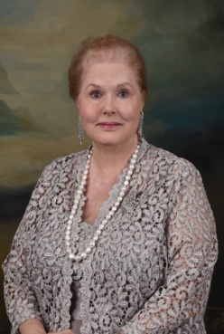 Thank you for the high honor to serve as your President General. It is with grateful appreciation that I submit the first annual report of the Order in this administration. All the officers and chairmen are to be commended for their dedication and attention to detail. Founder, Inaugural and Honorary President General Charles Bryan Poland and those first officers left the Order in an excellent position to further the interest in celebrating the

history of Scottish Royalty. Membership growth continues as a natural outcome of Alba's image in the greater Hereditary Community.

Last Spring the Treasurer and this officer completed the requirements of serving as signers for the Order's financial records. The Incorporation status was renewed with the Commonwealth of Virginia. The Order's 501(c)(3) filing is current. The Journal of Alba, Volume 2, Issue 1, Summer 2019 Edition featured a greeting from this officer, a save the date for the Fifth Annual Gathering planned in Washington, DC that was recently cancelled due to the Corona virus, and a brief article about Saint Andrew, Patron Saint of Scotland.

This year it is a special privilege to announce University of Delaware Professor Siobhan Carroll as the first recipient of the King Kenneth MacAlpin Research Grant. Her photograph is featured later in this issue. Thank you to Messers Poland and Durie for serving with this officer to confirm Ms. Carroll's selection and to Registrar Grinnell for creating and preparing a certificate of award for the recipient. Grateful appreciation is extended to Vice President Mabee for two issues of the Order of Alba Directory the last of which was recently published in large copy with a splendid cover and mailed to the membership. Special thanks to Chaplain Garner for merging the membership lists of the seven orders for the invitations to the gala. that was cancelled.

This officer communicated with fellow officers as needed, and interfaced with the leaders of the other orders of The Royal Seven and the staff at The Army and Navy Club to secure the site and complete the details for the Inaugural Gala that has been rescheduled to April 12, 2021 with the same arrangements that were in place for this year. Members who had made reservations to attend are currently receiving full refund checks. Please mark your calendars for 2021.

For the heath and safety of all persons this leader and others cancelled the heritage meetings scheduled in Washington this month. The necessary business of this Order will continue online until further notice. Please know you are, each of you in my thought and prayers for safe passage through trying times. Blessings to you, your families, and your friends.

Psalms: 91

Carla Whitehurst Odom

*"Haste ye back"* for the Sixth Annual Gathering next year.

**TREASURER'S REPORT**

**Note: The review of the Treasurer General have been waived for the 2020 Annual Gathering due to the cancellation of all face to face annual gatherings that would have occurred in Washington, DC during the April Heritage Season.**

Order of Alba

Annual Treasurer General Report - Constance Brooks Paradiso

March 28, 2020

**Summary**

**Wells Fargo Simple Business Checking** Balance as of 3/26/20 $19,455.06

One outstanding check for Royal Seven $162.67

**Working Balance** as of 3/28/20 **$19,292.39**

**Wells Fargo Business Market Rate Savings** Balance as of 3/26/20 **$6505.47**

**Total Assets** as of 3/36/20 **$25,797.86**

**The Treasurer's report will be filed.**

**GENEALOGIST'S REPORT**

9 March 2020

Madame President General,

It is my pleasure to report that we have had nine (9) new members since April 2019. The last membership number issued was 152.

Of the nine new members, there were four (4) gateway ancestors who were new to the Order but not new to the Hereditary Society Gateway Ancestor list.

It has been my honor and pleasure to serve with you during this term of your administration and I look forward to continuing the fine working relationship we have established.

Respectfully submitted,

David Lawrence Grinnell, Registrar/Genealogist General

**All other reports received have been filed.**

**UNFINISHED BUSINESS**

**There has not been any unfinished business reported.**

**NEW BUSINESS**

**Nominating Committee**

**Article V, Section 4-Sub-section D, of the Order of Alba Bylaws state, "Every two (2) years in even numbered years, a Nominating Committee of no less than three (3) members shall be appointed by the President General to present a slate of officers for election. At least one member of the Nominating Committee must be a Governing Officer."**

**The membership shall be notified by the Nominating Committee of the proposed slate of officers at the Sixth Annual Gathering in 2021.**

**Tim Mabee has been appointed Chairman, Suzanna Rawlins and Ann Garner have agreed to serve with him. If you should receive a call to accept a nomination for the 2021-2023 slate please consider saying yes.**

**KING KENNETH MacALPIN RESEARCH GRANT**

**It is a great honor to reconfirm the first King Kenneth MacAlpin Research Grant recipient Professor Siobhan Carroll, who serves on the faculty at the University of Delaware.**

**Thank you to Founder, Honorary President General Charles Poland, Chairman, and Shennachie Bruce Durie, Ph.D. for their service on the Research Grant Committee with this officer to determine the selection.**

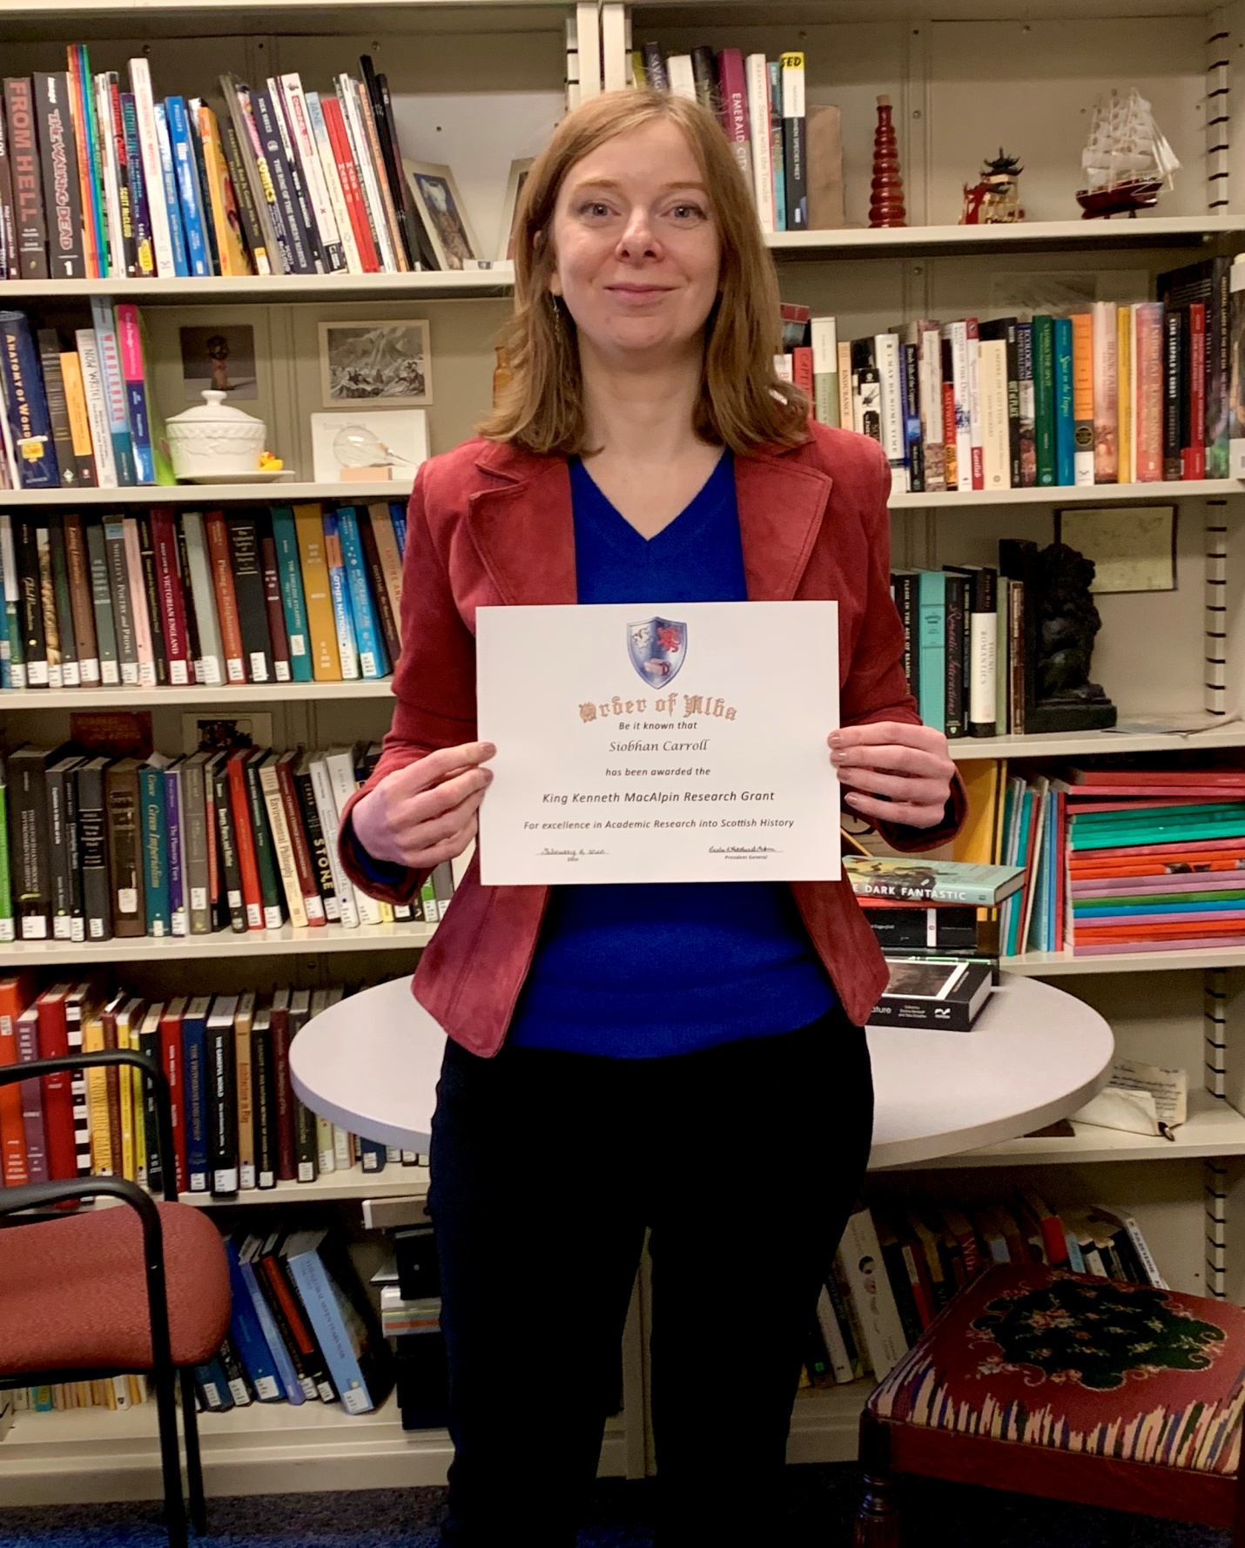

University of Delaware Professor Siobhan Carroll is awarded the King MacAlpin Research Grant.

**ANNOUNCEMENTS**

**On January 21, 2020 this officer received confirmation that her request for recognition of the Order of Alba had received a positive response by the National Gavel Society. Additionally she proposed Founder, Honorary President General Charles Poland for membership. He was invited and has been confirmed to membership.**

**Please remember the Sixth Annual Gathering is tentatively scheduled for April 12, 2021. Confirmation of this date and other details will be made available to the membership as soon as arrangements are complete.**

**ADJOURN**

**The Sixth Annual Gathering of the Order of Alba is adjourned. To reaffirm a traditional Scottish farewell, "Haste ye back."**

[](https://en.wikipedia.org/wiki/File:Flag_of_Scotland.svg)

*Saint Andrew's Cross, adopted in the 15th century, the Saltire is the Flag of Scotland.*

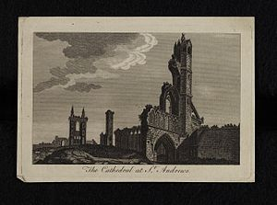

*(St. Andrew's Cathedral, Scotland)*

*Carla Odom, Editor*